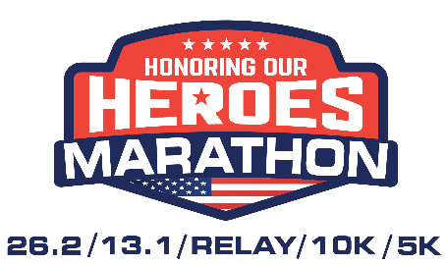
Mail In REGISTRATION FORM
Mail completed form to: HEROES Marathon, PO Box 194, Salem, MO 65560
Participant Information
First Name:________________________________Last Name:_______________________________________________________
Birthdate: _____/_______/_____________ Age on Race Day:____________ Gender (circle) M F
Address:____________________________________ City _______________________ State____________Zip Code__________
Phone Number: (______)______-____________ Email Address: ____________________________________________________
Veteran? (circle) yes no Active Military? yes no Branch of the Military:______________
Emergency Contact Name:___________________________________________________ Phone (_____)______-______ Relationship:________________________
Shirt Size (circle) S M L XL XXL
EVENT: Will you be running virtually, or as part of the physical event? (circle) In Person Virtual (add $6 mailing fee)
DISTANCE: (check one) _____ 5K ____10K _____Relay Marathon _____Half Marathon ______ Marathon
Dates for Pricing | Marathon | Half | Relay (must submit 4 forms) | 10K | 5K
1/1- 6/29 | $75 | $55 | $140 | $35 | $25
6/30 - 9/29 | $80 | $60 | $160 | $40 | $30
9/30- 10/30 | $85 | $65 | $180 | $45 | $35
10/31- 11/12 | $90 | $70 | $200 | $50 | $40
11/13-Race Day | $100 | $80 | $220 | $60 | $50

EXPO/PASTA PARTY is held the evening before the race; check our website for details. It is free to any registered participant. Additional guest tickets are available for $8 each for adults and $4 for youth under 12. Will you be attending the EXPO/PASTA PARTY? ______yes _________no Guests? ____adults _____youth
TOTAL AMOUNT ENCLOSED: $______________Checks payable to ‘Honoring our Heroes Marathon’
WAIVER: In consideration of this entry acceptance, I, my heirs, executors and administrators, hereby waive any and all rights of claim for damages I may have against the Honoring our Heroes Marathon Board, Dent County Commons, Rolla Lions Club, City of Rolla, Dent and Phelps Counties, and all sponsors and co-sponsors, and any and all individuals associated with the above for any and all injuries sustained by me in this event. I will additionally permit the use of my name and pictures in website, social media, broadcast, telecasts, magazines, newspapers, brochures, etc. I also understand the entry fee is non-refundable and non-transferable. I further attest and verify that I am physically fit and have sufficiently trained for competition and my physical condition has been verified by a licensed medical doctor. THIS WAIVER MUST BE SIGNED BY EACH PARTICIPANT REGISTERED. Athletes who participate may be subject to a formal drug testing in accordance with USA Track & Field Regulation 10 and US IAAF Rule 55. Athletes found positive for banned substances, or who refuse to be tested, will be disqualified from this event and lose eligibility for future competition. SOME OVER THE COUNTER MEDICATIONS CONTAIN BANNED SUBSTANCES. Information regarding drugs and/or drug testing may be obtained by calling the CDC Hotline at 800-233-0393.
Signature of Athlete:_______________________________________________________Date:_______/_______/____________ (signature of parent or guardian if under 18)

